**27 Amines, amides and amino acids**

**Topic summary**

**•**  **Amines** are weak organic bases, reacting with acids to form salts, and dissolving in water to give alkaline solutions.

**•**  There are three types of amine – **primary**, RNH2, **secondary**, R2NH, and **tertiary**, R3N.

**•**  Aryl amines react with nitric(III) acid (nitrous acid) to form **diazonium salts**, from which many useful **azo dyes** are manufactured.

**•**  **Amino acids** contain the –NH2 and –CO2H functional groups adjacent to each other. In solution and in the solid they exist as **zwitterions**, +NH3CHRCO2−.

**•**  Most amino acids are chiral. Those isolated from natural proteins have the ‘*l*’ configuration.

**•**  Electrophoresis can be used to separate amino acids and peptides.

**•**  **Synthetic polyamides** such as nylon are made by condensing diamines with dicarboxylic acids.

**Key reactions you should know**

    (R = alkyl or aryl unless otherwise stated)

**•**  Amines:

**•**  Alkylation:  
R–NH2 + CH3Br → R–NHCH3 + HBr

**•**  Acylation:  
R–NH2 + CH3COCl → R–NHCOCH3 + HCl

**•**  With nitrous acid (nitric(III) acid):

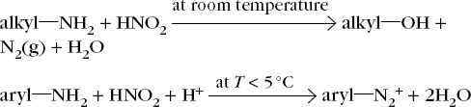

**•**  Amides:

**•**  Hydrolysis:

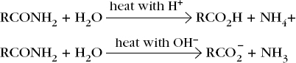

**•**  Reduction:

http://reader.dynamic-learning.co.uk/epub_content/9781471840494/OEBPS/images/ts_27-3.jpg

**•**  Polymerisation:

http://reader.dynamic-learning.co.uk/epub_content/9781471840494/OEBPS/images/ts_27-4.jpg